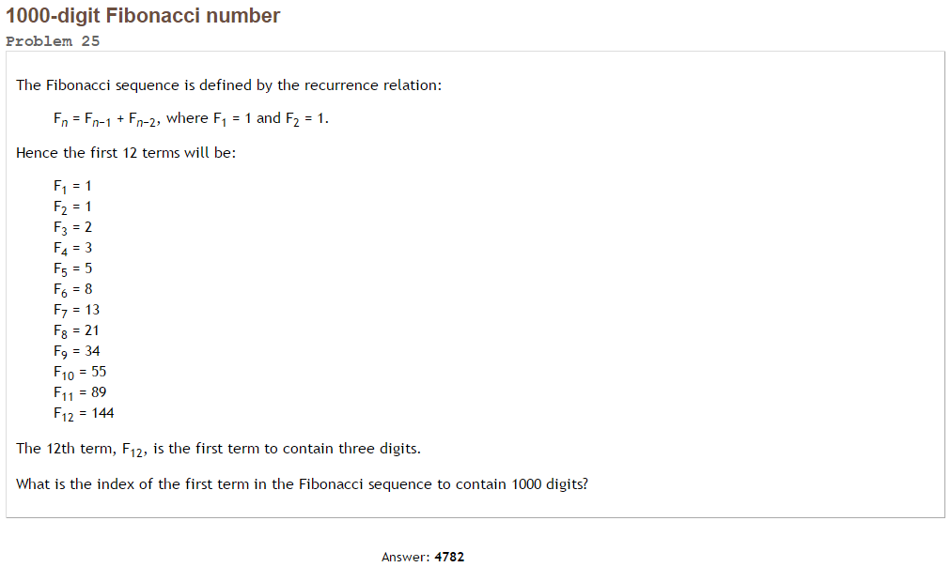Project Euler #25 – Pen & Paper Solution

We know the [closed formula for Fibonacci numbers](https://en.wikipedia.org/wiki/Fibonacci_number#Relation_to_the_golden_ratio):



For large values of n, the right addend become negligible.

We can approximate:.

We can use the inverse formula: 

= [4782](http://www.wolframalpha.com/input/?i=ceil%28++log%28%281+%2B+sqrt%285%29%29+%2F+2%2C+10%5E999+*+sqrt%285%29+%2B+0.5%29%29).